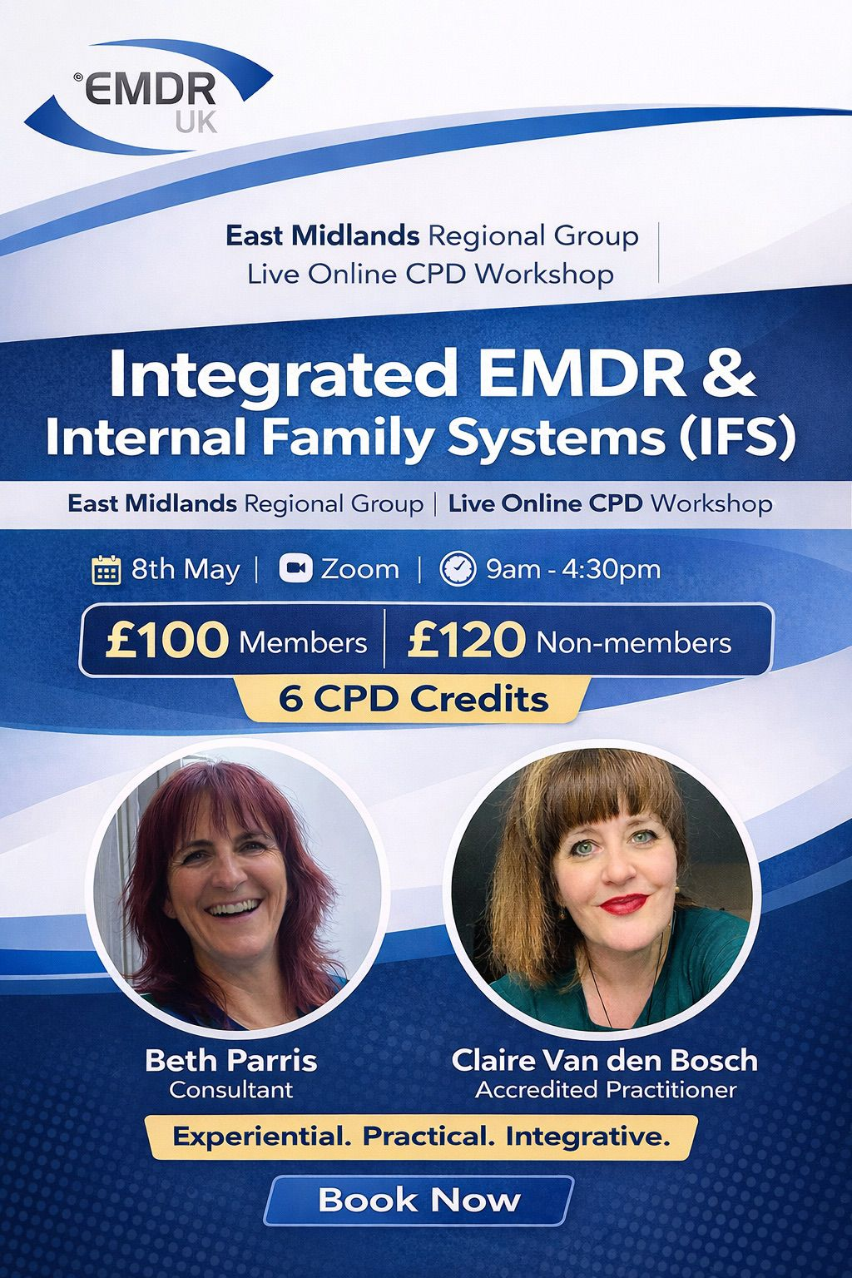

The East Midlands Regional Group of EMDR Association UK is excited to invite you to a dynamic and experiential online CPD workshop:
Integrated EMDR & Internal Family Systems (IFS)
📅 8th May
💻 Live Online via Zoom
🎓 6 CPD Credits
💷 £100 Members | £120 Non-members
Join Beth Parris and Claire Van den Bosch, EMDR Accredited Practitioners and IFS Level 3 trained therapists, for a powerful exploration of how EMDR and Internal Family Systems can work together to transform your clinical practice.
This is not just theory.
This is practical, experiential, and immediately applicable.
What you’ll explore:
✨ A clear, grounded understanding of IFS and why working with parts matters
✨ How to integrate IFS thinking across all 8 phases of EMDR
✨ Working with clients’ parts and your own therapist parts
✨ Deepened case conceptualisation
✨ Greater flexibility and confidence in complex presentations
The day includes:
• Guided experiential exercises
• Live experiential mapping demonstration
• Group reflection and discussion
• Structured opportunities to practise
If you want to expand your therapeutic toolbox and bring more nuance, clarity and confidence into your EMDR work, this workshop will stretch and strengthen your practice.
Places are limited.
👉 Book your place here: Also, this is the link for the ticket draft https://fienta.com/integrated-emdr-internal-family-systems-ifs

We look forward to welcoming you online.
East Midlands Regional Group
EMDR Association UK

